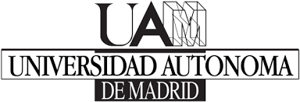****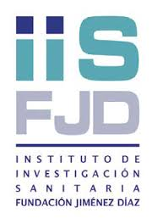

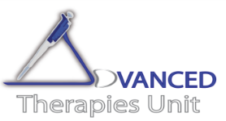 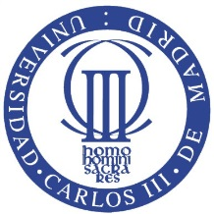

**Whole-organ bioengineering: current tales of modern alchemy**

**Speaker: Pedro M. Baptista, PharmD, PhD**

**Instituto de Investigación Sanitaria de Aragón (IIS Aragón), Zaragoza, Spain.**

**CIBERehd, Zaragoza, Spain.**

**7 de Julio, 13:30 horas Aula Francisco Grande, IIS-Fundación Jiménez Díaz**.

**Avda. Reyes Católicos, 2 Madrid**

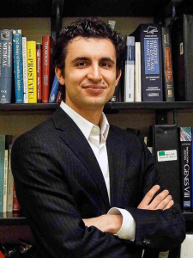

Organ transplantation is presently the only proven therapy able to extend survival for end-stage organ disease. It is also the only treatment for most of severe acute organ failures and to some forms of inborn errors of metabolism. Nevertheless, the waiting list for organ transplantation is long and many patients will not survive long enough to receive an organ due to the dramatic shortage of donors or lack of eligibility. This distressing donor shortage is common to most solid organs like the liver, lung, heart and kidneys.

In light of the grim situation of organ transplantation, our laboratory has recently developed a method to generate an entire liver scaffold from whole animal livers, using tissue decellularization that preserves the organ’s vascular network. This same method is also able to decellularize other solid organs generating specific acellular kidney, lung, intestine, pancreas or heart scaffolds. Our subsequent studies showed the possibility to efficiently recellularize the liver bioscaffolds by perfusing them with human fetal liver progenitor and endothelial cells in a perfusion bioreactor. The outcome was a bioengineered human liver. These liver constructs displayed typical hepatic phenotypic markers and bile ducts, and some vital human liver functions, such as drug metabolism, protein synthesis/secretion and catabolism. These results demonstrate the feasibility of generating bioengineered human liver organoids using acellular organ scaffolds and primary human cells. Furthermore, the bioengineered liver tissue is now being useful in several different applications like cord blood derived hematopoietic stem cell expansion and differentiation, drug metabolism, stem cell biology and mechanobiology. Altogether, this technology has the potential to shape novel developments in other scientific fields and ultimately, change transplantation medicine and the treatment of end-stage organ diseases.

**Contacto: Marcela del Río (mrnechae@ing.uc3m.es) y Raquel Largo (**[**RLargo@idcsalud.es**](mailto:RLargo@idcsalud.es)**)**